***Landowner Report***



***Station Information***

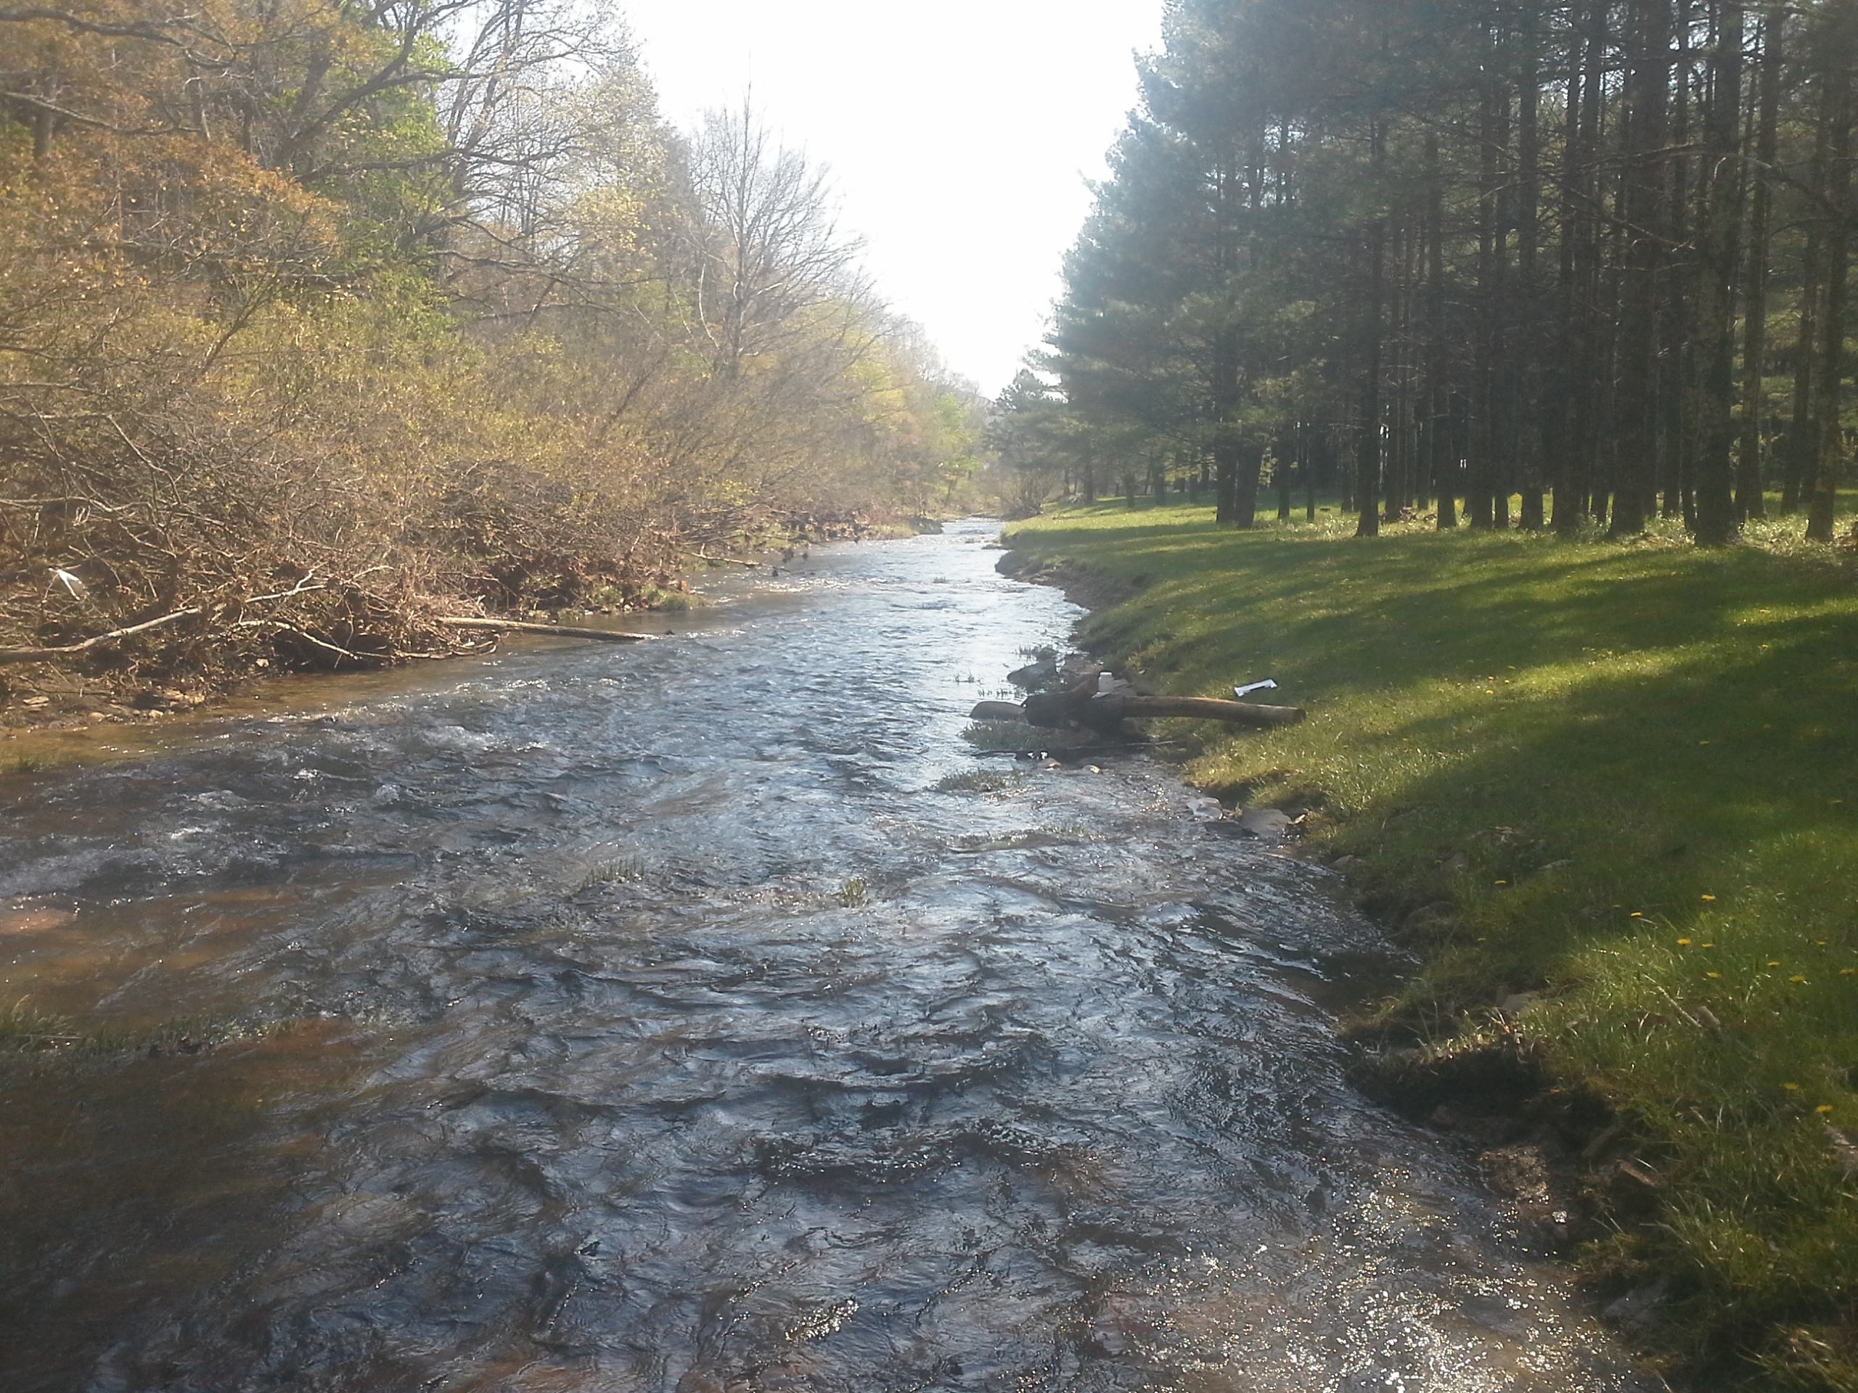

***Station ID*** 9-LWK023.25

***Stream Name*** Little Walker Creek

***Description*** Along Rt. 601

***Year*** 2015

***Regional Office*** BRRO

***County***  Bland

***Basin***  New River Photo of sampling station

***Data Results***

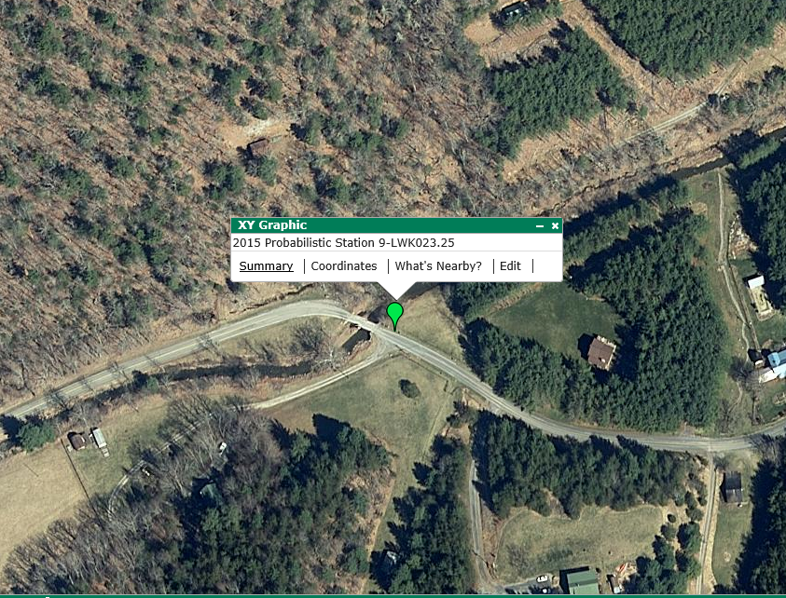

***Spring Fall Status***

***Temperature (C/F)*** 10/50 14.5/58 Optimal

***Dissolved Oxygen (mg/l)*** 8.5 9.0 Optimal

***pH*** 8.5 7.6 Optimal

***Conductivity (uS)*** 65 243 Optimal

***Bacteria (cfu/100ml)*** 50 Optimal

***Total Nitrogen (mg/l)*** 0.08 0.13 Optimal

***Total Phosphorus (mg/l)*** 0.01 0.02 Optimal

***Metals Index (ccu)*** non-detect Optimal Location of sample site

***Biological Index (0-100)*** 76.3 68.8 Optimal

***Habitat Index (0-200)*** 148 144 Sub-optimal

*The 'Landowner Report’ is not an official site specific VDEQ water quality assessment. This report summarizes water quality findings based on a limited sampling event. The primary application of probabilistic monitoring data is to establish regional/statewide water quality conditions and not to perform a site specific characterization. Please see the enclosed insert for more information.*

***Biologist Comments*:**

This site was sampled as a part of the Probabilistic Monitoring Program in 2015. The station was in a remote section of the Smith River several miles above the headwaters of Philpott Reservoir and about six miles below Iron Bridge Road. Biomonitoring surveys of aquatic macroinvertebrates resulted in high numbers of pollution-sensitive taxa such as mayflies, stoneflies, and caddisflies. Scores for habitat surveys were exceptional for most parameters due to the remote location of the sample site and lack of human impacts in this reach of the river. Sediment deposition received suboptimal scores. Fish community sampling resulted in a mix of suckers, minnows, darters, and a few game species such as smallmouth bass, rock bass, and sunfish.

***Biologist Contact Information:***



Larval stonefly “indicator of good water quality”

*George Devlin*

*Regional Biologist*

*VDEQ Blue Ridge Regional Office*

*3019 Peters Creek Road*

*Roanoke, VA 24109*

*Phone: 540-562-6826*

*Email:* [*george.devlin@deq.virginia.gov*](mailto:george.devlin@deq.virginia.gov)